Submitted By: Aiman Ismail

Task 1: Model Testing
In this task, the trained CNN model was loaded and evaluated using the test dataset containing normal and pneumonia chest X-ray images. The test images were pre processed by resizing them to 224 × 224 pixels and normalizing the pixel values. The model was then evaluated using TensorFlow's evaluate() function, which calculated the test accuracy and test loss. These metrics indicate how well the trained model performs on previously unseen data.

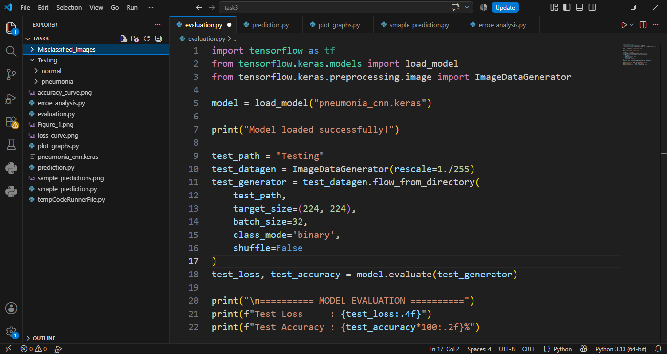
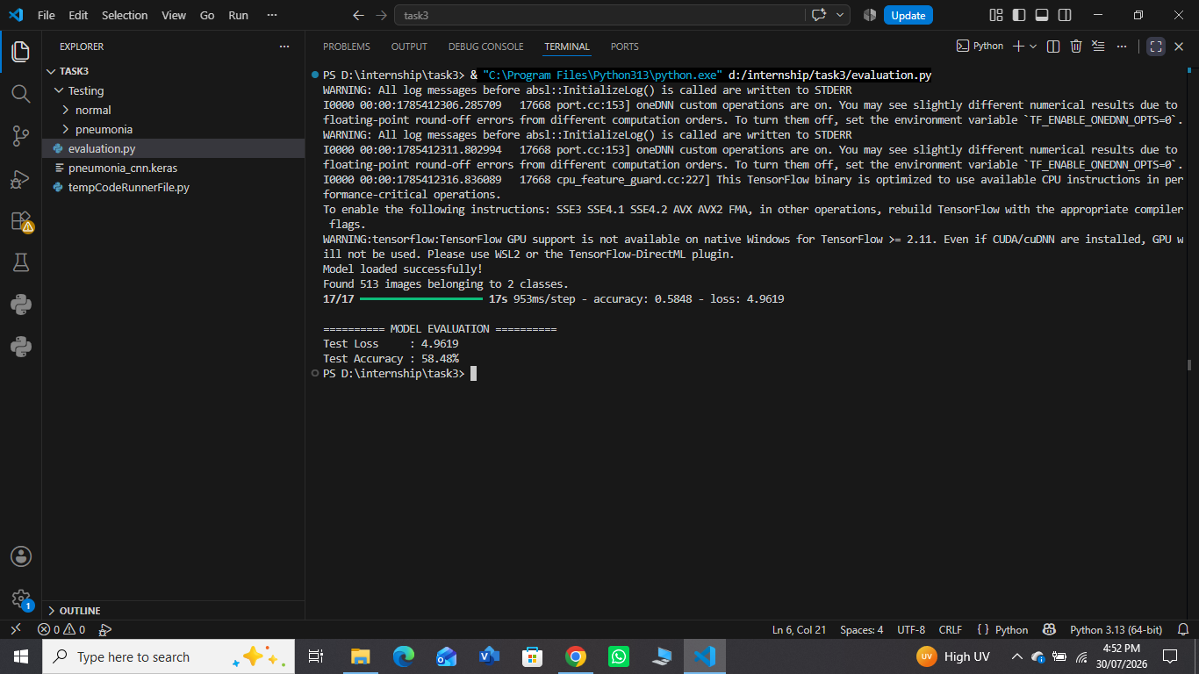

Task 2: Performance Metrics
After evaluating the model, additional performance metrics were calculated to obtain a more comprehensive assessment of its classification performance. These metrics include Accuracy, Precision, Recall, and F1-score. A Confusion Matrix was generated to visualize the correct and incorrect predictions, while a Classification Report summarized the evaluation metrics for each class. These measures provide a deeper understanding of the model's effectiveness beyond overall accuracy.
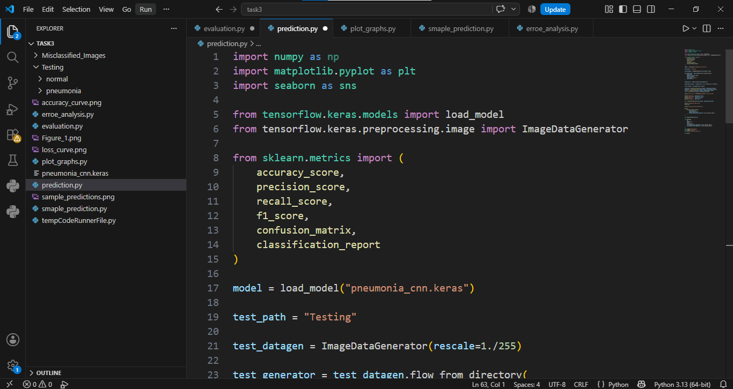
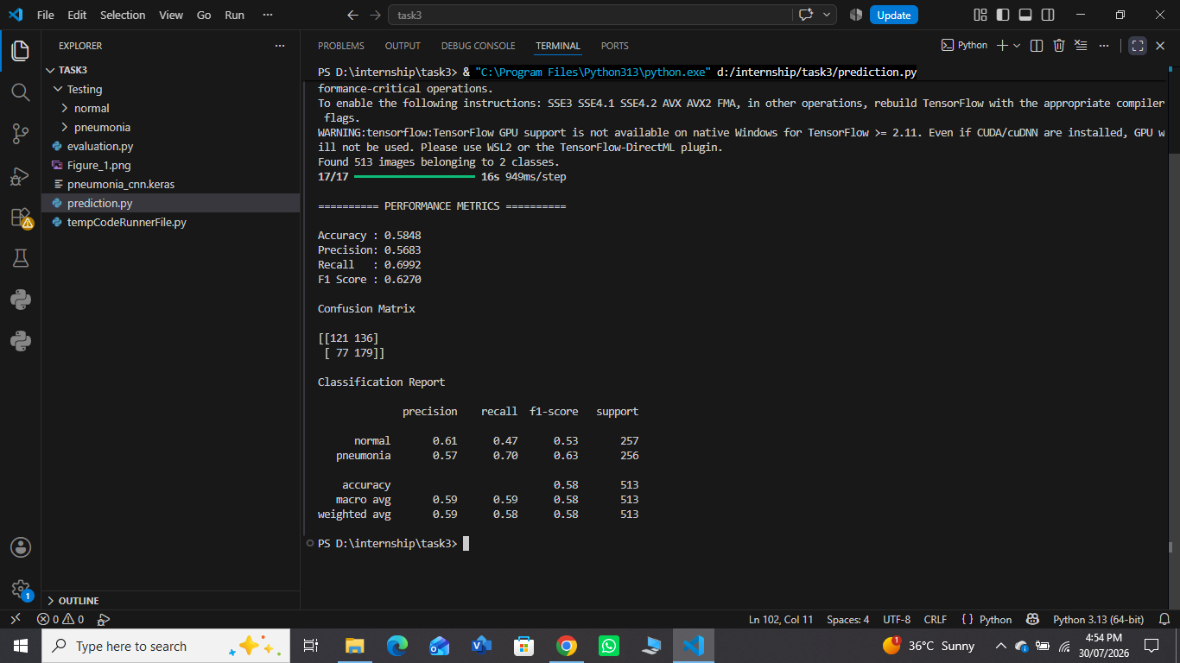
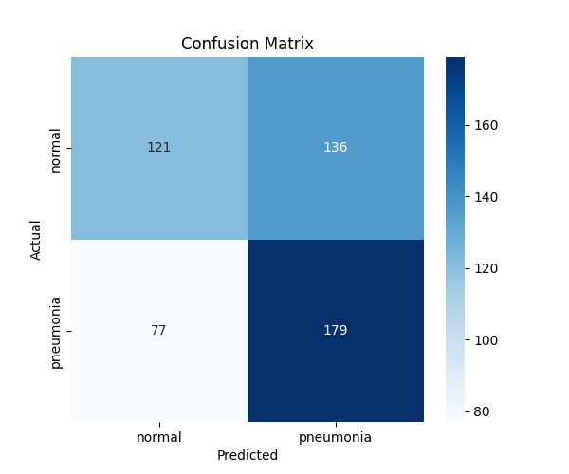

Task 3: Result Visualization
In this task, various graphs and visualizations were generated to analyse the model's performance. The training and validation accuracy curves illustrate how the model's accuracy changed during training, while the loss curves show the reduction in prediction error across epochs. In addition, the confusion matrix was visualized, and sample correctly classified and incorrectly classified images were displayed with their actual and predicted labels. These visualizations provide a clearer understanding of the model's learning behaviour and prediction quality.

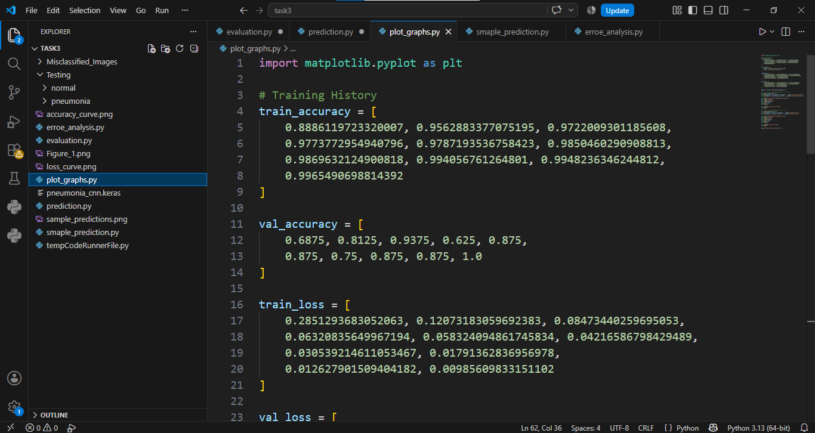
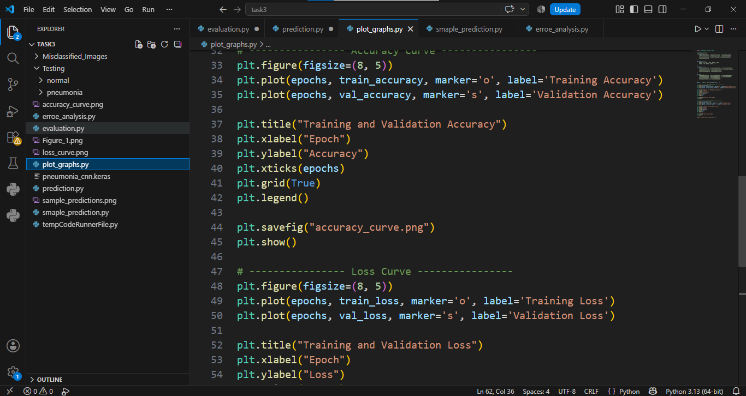
Accuracy Curve:
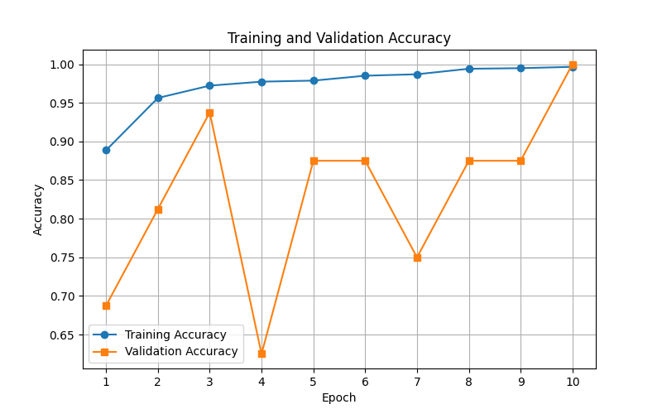
Loss Curve:
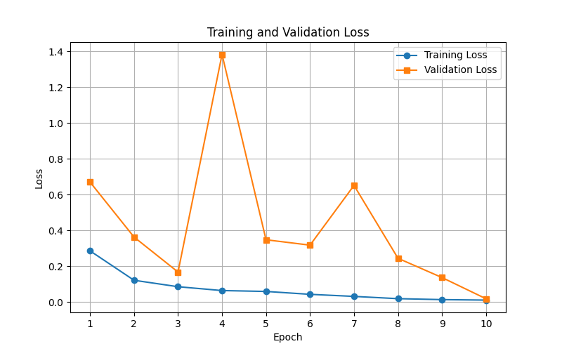
Confusion Matrix:

Sample Predictions:
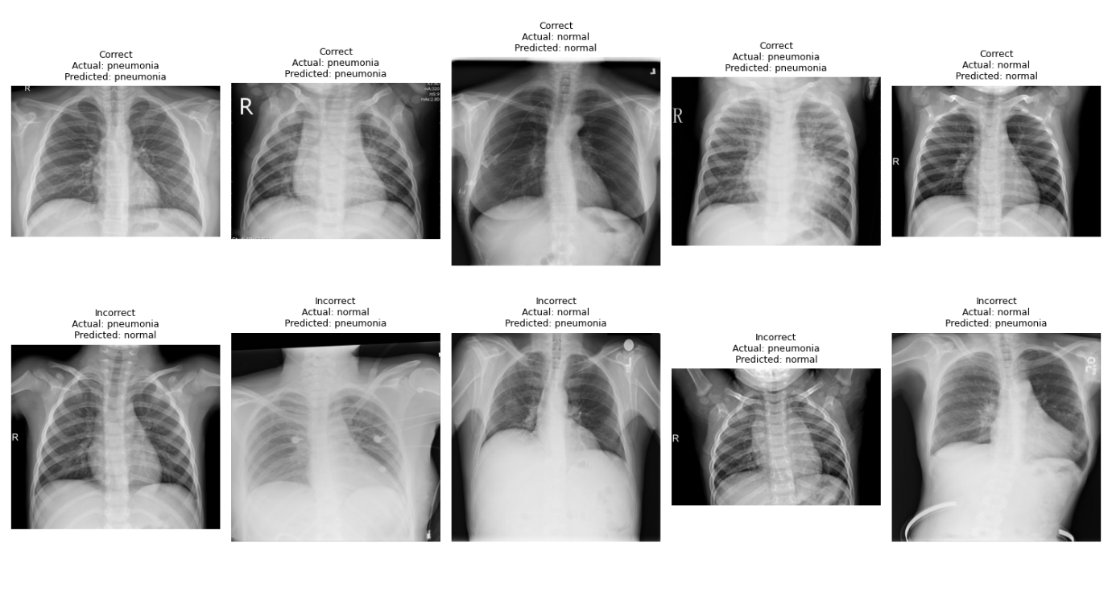

Task 4: Error Analysis
The selected 10 images are in the folder Misclassified_Images.
Overview
To better understand the limitations of the proposed Convolutional Neural Network (CNN), an error analysis was conducted on the test dataset. Although the model achieved high classification performance, a detailed examination of the misclassified chest X-ray images is essential to identify potential weaknesses and guide future improvements. A total of ten misclassified images were selected from the testing dataset for qualitative analysis.

Analysis of Misclassified Images
The selected misclassified samples reveal several common characteristics that may have influenced the model's predictions.

1. Subtle Disease Manifestations
Some pneumonia images exhibited only mild pulmonary infiltrates with limited visual abnormalities. These subtle pathological changes closely resembled normal lung structures, making it difficult for the CNN to distinguish between healthy and infected lungs. Consequently, these samples were incorrectly classified as normal.

2. Variability in Chest X-ray Acquisition
Chest X-ray images are acquired using different imaging devices and clinical protocols. Variations in patient positioning, exposure level, image contrast, and illumination introduce inconsistencies within the dataset. Such variability may reduce the model's ability to generalize across unseen samples.

3. Low Image Quality
Several misclassified images showed reduced contrast, motion blur, or imaging noise. These quality-related issues can obscure clinically significant features, limiting the effectiveness of feature extraction performed by convolutional layers.

4. Similarity Between Classes
In clinical practice, early-stage pneumonia may present with radiographic features that are visually similar to healthy lungs. Likewise, certain normal anatomical structures may resemble pathological patterns. This overlap between classes increases classification complexity and may result in incorrect predictions.

5. Model Generalization Limitations
The CNN learns representative patterns from the available training data. If uncommon pneumonia presentations are underrepresented during training, the model may struggle to recognize these cases during testing, leading to reduced performance on rare image patterns.

Possible Improvements
The following strategies could further improve the robustness and diagnostic performance of the proposed model.
1. Data Expansion
Increasing both the size and diversity of the training dataset would expose the model to a broader range of pathological variations, thereby improving generalization performance.

2. Advanced Data Augmentation
Applying augmentation techniques such as random rotation, horizontal flipping, brightness adjustment, scaling, and contrast enhancement can generate more diverse training samples while reducing overfitting.

3. Transfer Learning
Pre-trained deep learning architectures, including DenseNet121, ResNet50, EfficientNetB0, and ConvNeXt, have demonstrated superior performance in medical image classification. Fine-tuning these networks may significantly improve classification accuracy.

4.Hyperparameter Optimization
Systematic optimization of learning rate, batch size, optimizer configuration, dropout rate, and the number of training epochs may improve convergence and reduce generalization error.

5. Explainable Artificial Intelligence (XAI)
Incorporating visualization techniques such as Grad-CAM, Grad-CAM++, or Score-CAM would enable interpretation of the model's predictions by highlighting the lung regions that contribute most strongly to the final classification. This improves clinical interpretability and supports physician confidence.

6. Dataset Balancing
Ensuring balanced representation of both normal and pneumonia images can reduce prediction bias toward the majority class and improve overall classification performance.

Conclusion
The conducted error analysis provides valuable insight into the behaviour of the proposed CNN model beyond quantitative evaluation metrics. While the model achieved high predictive performance, the analysis of misclassified images highlights opportunities for further enhancement through improved data quality, advanced preprocessing, transfer learning, and explainable AI methodologies. These improvements are expected to increase both the robustness and clinical applicability of the proposed pneumonia detection framework.

CNN Workflow:
